Practice this only in Service-Now Demo instance

Assignments

**Screen Shot:-**

1. Create the Order Guide that should contain a select box field(e.g.-category), In that category select box, the value should contain the name of Record Producer , based on the selection user can able to see the particular record Producer.
2. Create a two select box e.g.:-category and sub category and based on category value, sub category select box need to populate. For the dependent condition write a client script.
3. Create a help link which will provide the details about the field e.g.:-create a list collector field and provider the Help info link.

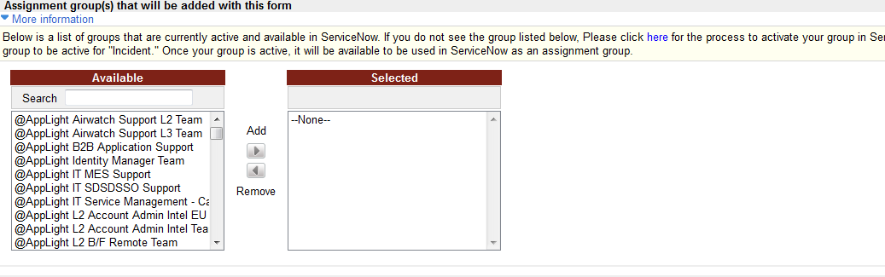

1. Write a Client script for change the Label of List collector.
2. Write a client script to hide the filter of list collector.
3. Write a client script for decreasing the width and height of list collector.

**Screen Shot:-**

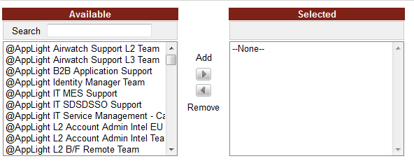

1. Write a small scenario to create the variable set. (Create the two check box field (e.g.:-Change Work flow option and other changes, not listed above) and keep those two variables under the variable set.

**Screen shot:-**



1. Write small scenarios to hide unhide the set of fields, when user will click the check box then field should be visible and if unchecked then field should be hiding.

**Screen shot:-**

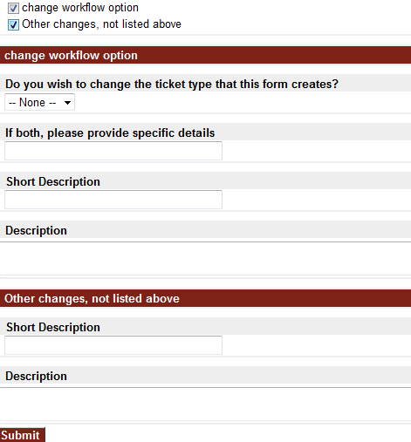

1. Write a client script to make the fields and Check Box Read-only.

**Screen Shot:-**

